Name of view: Decomposition Model View

Primary Presentation:

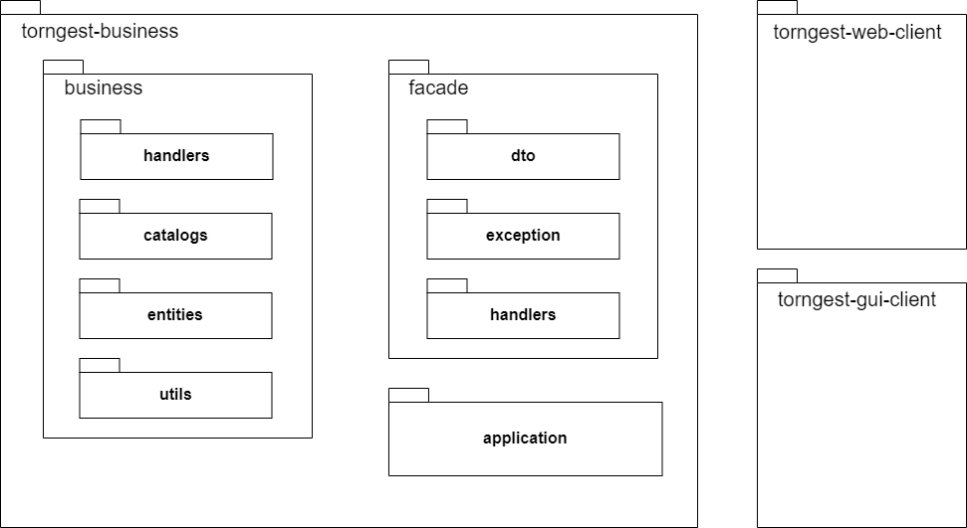

Element Catalog:

* torngest-business – This module contains all the business logic necessary for the 4 use cases implemented in the system
* business – this package contains the main processing logic require for any type of input from the user
* handlers – the handlers package contains a set of handlers which will take care of the information treating required for every use case implemented. These will have access to entity catalogs from which data will be set and retrieved.
* entities – the entities package contains all the database entities which define the columns and their respective values. Also defined within the classes of this package are JPQL queries used to access data from the database.
* utils – this package contains a helper class used to calculate the scores of a match
* façade – this package contains the main implementation of the façade design pattern, mainly used to mask the underlying business logic complexity
* dto – this package contains all the DTOs (Data Transfer Objects) required to send requested data through method calls on both the GUI and Web clients
* exception – the exceptions package contains custom exceptions which are thrown according to the business logic implementation
* handlers – this package exposes the interface of the 2 main services from which the main method calls required for all the use cases are implemented, these remote interface will then be injected into both the GUI and Web client from which they will have access to the business logic layer
* application – this package contains the implementation of both main services required for the correct functioning of the system. The CalendarioService which will deal with all date viewing functionalities and TorneioService which will deal with viewing set matches, creating new matches between players and adding new players to the database
* torngest-web-client – This module contains the web client accessed through a browser which will let the user, store the result of a given match and view the upcoming matches of a give player or team
* torngest-gui-client – This module contains the GUI interface which will access the business logic through RMI calls